ORDER FORM

3er / Condoms
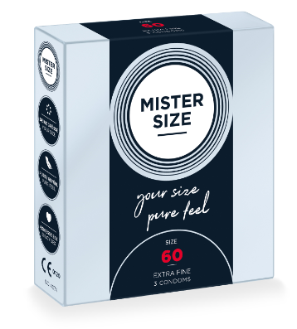 | Condom Size | Item No. | Quantity
 |  |  | Tray / VE  (12 boxes per Tray / VE) | SU  (288 boxes per SU)
 | 47 | MS 4703
 | 49 | MS 4903
 | 53 | MS 5303
 | 57 | MS 5703
 | 60 | MS 6003
 | 64 | MS 6403
 | 69 | MS 6903

10er / Condoms
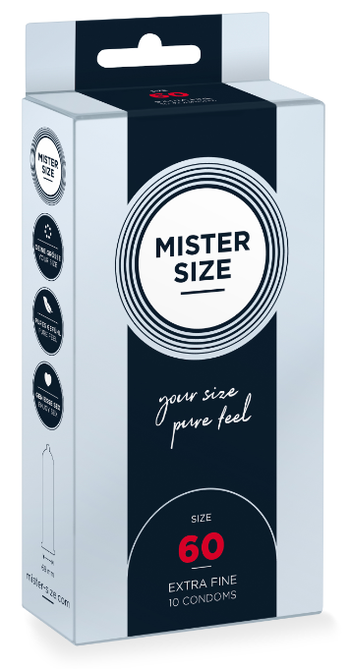 | Condom Size | Item No. | Quantity
 |  |  | Tray / VE  (6 boxes per Tray / VE) | SU  (120 boxes per Tray / VE)
 | 47 | MS 4710
 | 49 | MS 4910
 | 53 | MS 5310
 | 57 | MS 5710
 | 60 | MS 6010
 | 64 | MS 6410
 | 69 | MS 6910

36er / Condoms
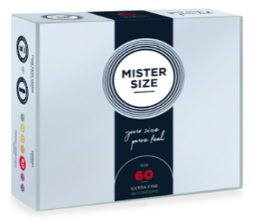 | Condom Size | Item No. | Quantity
 |  |  | Tray / VE  (6 boxes per Tray / VE) | SU  (60 boxes per Tray / VE)
 | 47 | MS 4736
 | 49 | MS 4936
 | 53 | MS 5336
 | 57 | MS 5736
 | 60 | MS 6036
 | 64 | MS 6436
 | 69 | MS 6936

Please send your order to info@mister-size.com
Thank you!

